ROTOR RETURN FORM  MICROP TECHNOLOGY (TAIWAN), INC.  No. 40, Junghe Tsuen, Minshiung Township  Chiayi County 621, Taiwan (R.O.C.)  Notification  The warranty excludes the abuse, improper assembly, improper maintenance, dropping the handpiece, repeatedly or intentionally extending burs, or any other action inconsistent with the operating instructions… | 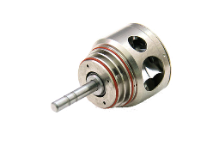  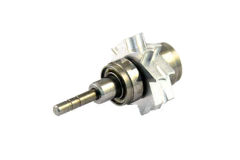

Date | Model Number | Serial Number | Defective Part
Picture and Description:

Date | Model Number | Serial Number | Defective Part
Picture and Description:

Date | Model Number | Serial Number | Defective Part
Picture and Description:

Date | Model Number | Serial Number | Defective Part
Picture and Description:

Next Step

- We will reply you in 24 hours and see if return parts are necessary.
- If shipping back is necessary, then please send it to No. 40, Junghe Tsuen, Minshiung Township Chiayi County 621, Taiwan (R.O.C.), MicroP Technology Inc. with value lower than 100USD total.

